Innovation funding round-up | Don’t miss these great opportunities to drive innovation in your business!
👉 Eureka Eurostars 3: call for innovative SMEs
Funding for collaborative R&D and industrial research
Deadline: 24 March - https://lnkd.in/dTBc3ZNm
👉 SBRI funding for innovation in cancer diagnosis
Funding for solutions that improve early detection of cancer
Virtual match-making: 24 March
Deadline: 24 May - https://lnkd.in/dAduaCxT
👉 GBIP in South Africa: Sustainable plastics
Opportunity for SMEs to explore innovative plastic waste solutions
Deadline: 28 March - https://lnkd.in/dtVAvC3z
👉 GBIP in the Netherlands: Women in Innovation Agri-Tech
Opportunity for female entrepreneurs to collaborate on Agri-Tech solutions
Deadline: 28 March - https://lnkd.in/dhVT9UcJ
👉 Life Sciences Innovative Manufacturing Fund
Funding for businesses investing in life sciences manufacturing
Deadline Wave 1: 31 March - https://lnkd.in/dnHhQapp
👉 GBIP in Canada: Biomanufacturing of advanced therapies
Opportunity for SMEs to explore biomanufacturing in Canada
Deadline: 31 March - https://lnkd.in/d9TEnfnf
👉 Innovate UK Smart Grants
Funding for game-changing & commercially viable R&D innovation
Deadline: 13 April - https://lnkd.in/dz-S2vAy
👉 CELTIC-NEXT call for innovative projects
Funding for next-generation communications projects
Deadline: 14 April - https://lnkd.in/dNGStrXV
👉 Green Innovation Challenge Fund pilot launched
Funding for innovative low carbon technologies
Deadline: 13 May - https://lnkd.in/dNkVfQpf

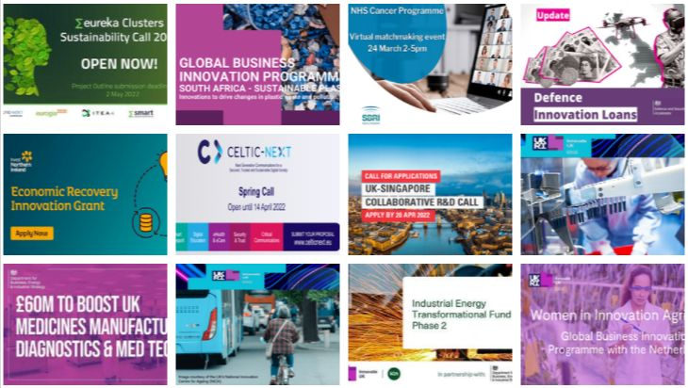

Innovation Funders

Innovate UK
- Catapult Programme https://catapult.org.uk/
- Other Competitions https://auth.apply-for-innovation-funding.service.gov.uk/idp/profile/SAML2/Redirect/SSO?execution=e1s1

Innovate UK EDGE NI https://www.innovateukedge.ukri.org/

Invest NI
- Grant for R&D https://www.investni.com/support-for-business/get-into-research-and-development
- Proof of Concept funding https://www.investni.com/support-for-business/proof-of-concept?gclid=COH_xMLzmMMCFanMtAodHk8AqA
- Innovation vouchers https://www.investni.com/support-for-business/innovation-vouchers
- Business Info Centre https://www.nibusinessinfo.co.uk/content/innovation-and-rd

Innovate NI
- Innovation Accreditation Programme https://www.innovateni.com/about-innovation

Defence and Security Accelerator https://www.gov.uk/government/collections/apply-for-funding

Queen’s University Belfast https://www.qub.ac.uk/Business/Commercialisation/IP-and-innovation/

Innovation Ulster Ltd https://www.ulster.ac.uk/research/collaboration-and-innovation/innovation-ulster-ltd

Eureka Network Open calls https://www.eurekanetwork.org/open-calls/

UK Research & Innovation
- Knowledge Transfer Partnerships https://www.ukri.org/opportunity/knowledge-transfer-partnership/
- Funding finder https://www.ukri.org/opportunity/

Department for Business, Energy and Industrial Strategy (BEIS)
- Innovation Loans https://www.nibusinessinfo.co.uk/content/ps150-million-innovation-loans-scheme-launched?utm_source=LinkedIn&utm_medium=Organic+Social&utm_campaign=Organic+Promotion+March+2022&utm_content=BN

The Institute of Innovation & Knowledge Exchange NI https://swc.ac.uk/news/the-institute-of-innovation-and-knowledge-exchange-ni-launched-at-south-west-college

InterTradeIreland https://intertradeireland.com/innovation/how-we-support-innovation

Centre for Advanced Sustainable Energy (CASE)
- Green Innovation Challenge Fund pilot https://www.nibusinessinfo.co.uk/business-support/green-innovation-challenge-fund

Carbon Trust https://www.carbontrust.com/what-we-do

